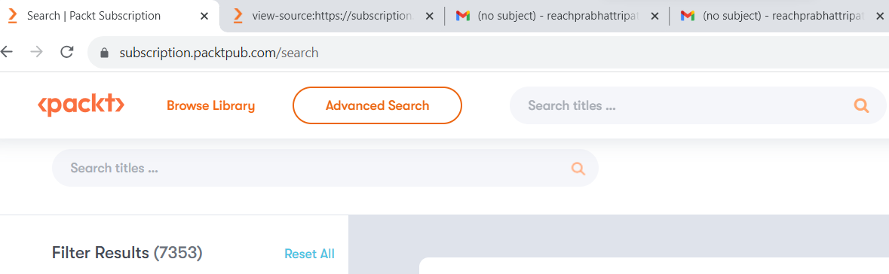

In the above screenshot, changed the colour of the Browse Library element from Blue to Orange.

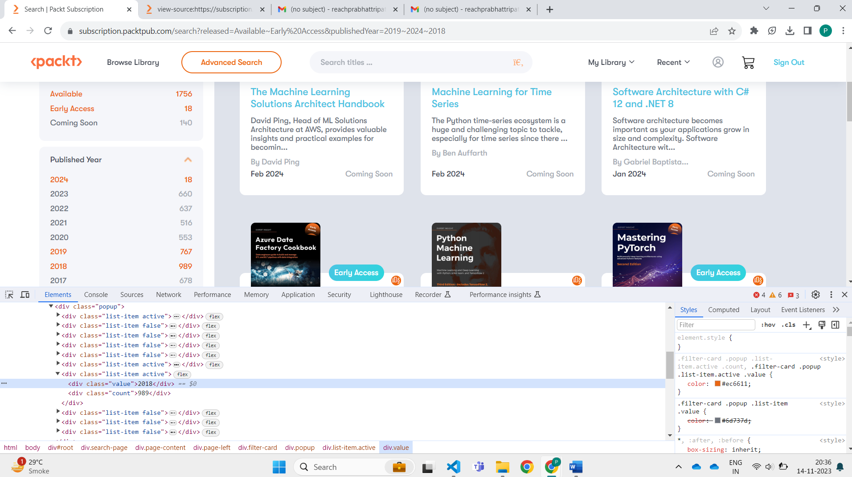

In above screenshot checked the filter for the published Year.

We have checked that once we click on the particular year its colour changes from blue to orange.